Create index.html file:

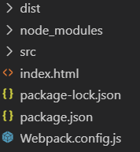

<html>

    <head>

    </head>

    <body>

        <script src="**./dist/main.js**"></script>

    </body>

</html>

Once the file opened, the entry (index.js) will run:

